The Design
- The ASLA roof design includes two elevated “waves” formed from rigid insulation and covered with a green roof system. The waves create a pleasant foliage-enclosed space and block the view of the rooftop HVAC systems. The north-end wave cantilevers over one of the larger HVAC units. One of the waves is planted primarily with sedums; the other wave, with slightly deeper soil, is planted with drought-resistant perennials and grasses as well as sedums.

- Surrounding these waves is an extensive green roof system covered by aluminum grating that allows visitors to walk over the plant material without damaging it. The innovative use of grating over sedum (as pictured below) for the central area and access path provides almost total green coverage for the roof while creating an area that can be enjoyed by the building occupants and accessed for maintenance.

- The designers made maximum use of the structural capacity of the building, varying soil depths and plantings to take advantage of differing load capacities. For example, the elevator shaft has the greatest structural capacity and could accommodate 21 inches of soil; plantings on the elevator shaft include sumac trees, which may grow as tall as 30 feet at maturity.

- As part of the project, ASLA extended an existing stairway to the roof level to provide access for viewing and using the roof space.
ASLA Green Roof Demonstration Project Fact Sheet
- Stewardship of the land has been part of the mission of the American Society of Landscape Architects since the Society was founded in 1899. So, in 2004, faced with the need to replace the existing roof on the Society’s D.C. headquarters building, the ASLA Board voted to install a green roof.

- The goals of the ASLA headquarters green roof are to maximize and serve as a demonstration project for the environmental benefits of green roofs, and to showcase what landscape architects contribute to this project type.

- The project began with a structural assessment to ensure that the roof could accommodate the additional load of a green roof, around 40 pounds per square foot for an extensive roof.
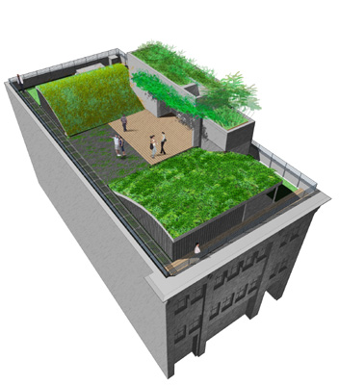

The Design and Construction Team
- Completed in spring 2006, ASLA’s green roof was designed by landscape architecture firm Michael Van Valkenburgh Associates, Inc., with consulting landscape architecture firm Conservation Design Forum. DMJM Design served as the project architect and Robert Silman Associates was the structural engineer.
The Project’s Origins and Purpose

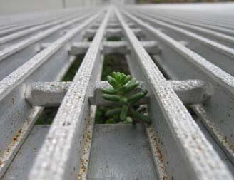
-Page 1 of 2-

The Benefits of Green Roofs
- Green roofs have significant benefits both for the public/community and for the individual building owner. Primary public benefits include controlling stormwater runoff, improving water quality, reducing the urban heat island effect, and improving air quality—all of which ASLA is committed to monitoring (see section below for details). The most significant benefits of green roofs for building owners are reductions in building operating costs, significantly longer roof life and lower life-cycle costs for the roof, and increased property value.

- Citywide green roof implementation has the potential to reduce the ambient air temperature in a city and help reduce the 'Urban Heat Island Effect', the distribution of dust and particulate matter throughout the city, and the production of smog.

- Because of the small amount of water-retaining green space in urban areas, stormwater systems can be overwhelmed during periods of heavy rains. In the many cities that have combined sewer systems, the result is the release of untreated sewage and stormwater into rivers and lakes. Green roofs, which can retain up to 75 percent of a one-inch rainfall, alleviate pressure on city’s overburdened sewer systems caused by stormwater. At the same time, the green roof serves as a filter to reduce pollutants in the water and also to lower the temperature of the water that is eventually returned to the watershed.

- Because of their insulating properties, green roofs reduce the heating and cooling costs for buildings by at least 10 to 15 percent. A Canadian study showed that a 6-inch extensive green roof can reduce heat gains by 95 percent.

ASLA’s Commitment to Green Roof Data Collection
- In order to gather data on the environmental benefits of green roofs, ASLA has committed to monitoring the performance of the roof over time for: stormwater retention; water quality; temperature; and plant growth.

- Although a green roof initially costs more than a conventional roof—$10 to $20 per square foot for a green roof versus $5 to $10 per square foot for a conventional roof—they more than make up for that difference over time. Green roofs extend the lifespan of the roof membrane significantly by protecting it from sunlight and temperature variations. As a result, green roofs can conservatively be expected to last two to three times longer than a conventional roof. Experience with green roofs in Germany shows that 40+ and 50+ life spans for green roofs should be expected.
-Page 2 of 2-
- Flow meters and rain gauges are in place. As displayed in the graph (to the right), the roof retained 77 percent of the 11.83 inches of rain that fell during the first data collection period.
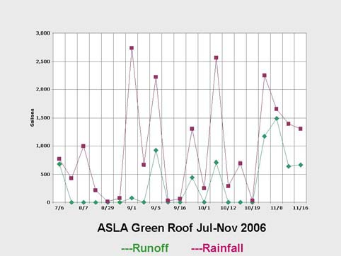

American Society of Landscape Architects, 636 Eye Street, NW, Washington, DC 20001
Phone: 202-898-2444. Green roof tours are available by appointment at www.asla.org.

- Temperatures on the ASLA roof have been as much as 59 degrees less than conventional black roofs on neighboring buildings.
- In addition, light meters have been placed in different areas and a number of plants tagged so that data on plant growth and growing conditions can be collected.
- An environmental engineering consultant was retained
to analyze and compare the water quality collected on the
roof and runoff collected from roof drains. The analysis
showed a significant reduction in nitrogen being introduced
back into the watershed due to the water retained. The
young green roof, showed higher amounts of some nutrients, such as phosphorus, and heavy metals in the runoff—but still below U.S. Environmental Protection Agency standards, and below levels from street runoff. These levels are expected to decrease in the coming years.

